Curriculum Vitae
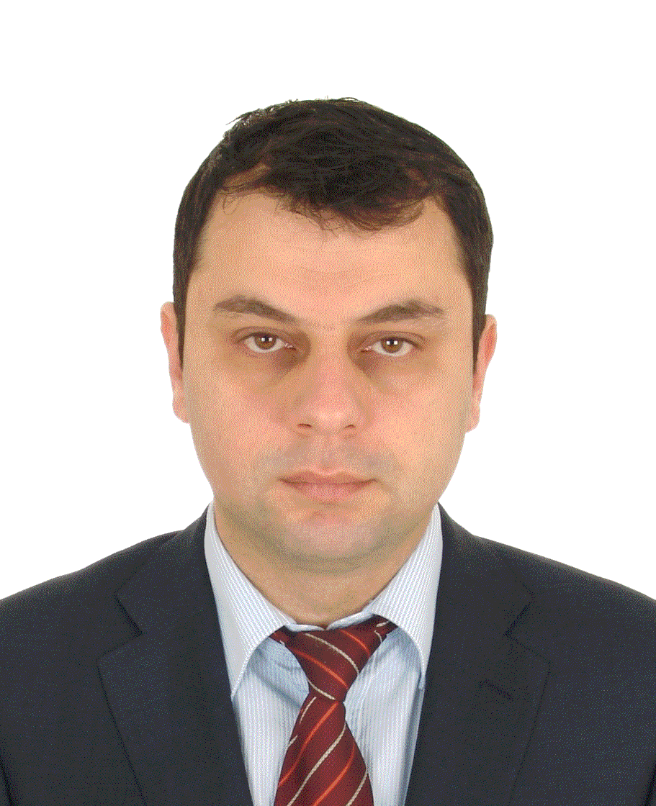

Name and Surname: Artan Haruni
Date of birth: 06-02-1974

Place of Birth: Vlora
Address: Selite, Tirana
Nr. Phone: ++355 68 20 66 561
E-mail address: artanharuni@hotmail.com
Marital Status: Married
Nationality: Albanian

Hobbies: Guitar Player

SCHOOL PREPARATION

1992 – 1998: University of Medicine Tirana
1998 - 2002: Specialization in Pediatrics (UHC “Mother Theresa”Tirana)
2004 - 2005: Specialization in Pediatric Neurology (UHC “Mother Theresa”Tirana)
2010 – 2015: Doctorature -University of Medicine, Tirana
ACADEMIC TITLE
Master in Pediatrics -University of Medicine, Tirana
PHD -University of Medicine, Tirana

WORK EXPERIENCE
2003 - 2008: Pediatrician – Polyclinic nr. 4 Tirana
2003 - 2004: Lecturer of Histology – University of Medicine Tirana
2009- 2010: Director- Polyclinic of Specialties nr. 3 Tirana
2008 - 2016: Pediatric Neurology Consultant – Polyclinic of Specialties nr. 3 Tirana
2010 - 2011: Lecturer of Pharmacology – University Vitrina, Tirana
2010 - 2016: Pediatric Neurologist ( Private practice)

ADDITIONAL COURSES AND TRAINING
17-6-2001 - 15-10-2001: Training in Pediatric Emergencies, ITALY
1-7-2003 - 10-7-2003: Integrated Management of Children Disease.
29-11-2004 - 13-12-2004: Training in Electroencephalography, ITALY
13-19 June 2007: Training course (CHOP) –Pediatric Neurology, AUSTRIA
13-14 May2008: Training course (EPNS) –Acute Neurology and Cerebrovascular Diseases, POLAND
27-7-2008 - 8-8-2008: Advanced International Course “Bridging Basic with Clinical Epileptology, ITALY
2009 - 2010: Training course (Virepa) -EEG in the diagnosis and management of epilepsy (6 Month) ONLINE
2010 – 2011: Training course (Virepa) -Clinical Pharmacology & Pharmacotherapy (6 month) ONLINE
2011 – 2012: Training course (Virepa) - EEG in the diagnosis and management of epilepsy in neonates snd children (6 month) ONLINE
31 May-1 June 2010: Training course (EPNS) –Epilepsy ROMANIA
2-3 June 2010: Training course (EPNS) –Central Motor Function Disorders, ROMANIA
14-19 June 2010: Training course (CHOP) –Pediatric Neurology and Metabolism, AUSTRIA
25-28 September 2010: Training course Treatment of Epilepsy-what every clinician should know. SWITZERLAND
8-11 March 2016 EPNS Training Courses in Budapest.
15 -19 June 2016: 2nd East European Course of Epilepsy, SRIE Summer School

Medical society membership

- President of Albanian Primary Healthcare Association
- Albanian Pediatric Society ( Board Member)
- APNS Albanian Pediatric Neurology Association ( Board Member)
- EPNS European Pediatric society association ( Member)
- ILAE international League Against Epilepsy (Member)
- Order of Physicans of Tirana (Board Member)

Professional and scientific works

VIth Balkan congress of medicine and dentistry for students and young doctors, November 2002, Ioonnina-Greece.
“Some haematological indexes in patients of pediatric age”.

10-^{th} MEDICO-CHIRURGICAL conference. TIRANA, 2002.
“Biological approach to onco-hematological patients treated with cytostatic drugs”.

6-^{th} annual conference of albanian pediatric association. November 2002, Tirana.
“ Kriptokidizm - experience of treatment with hormonal therapy”.

2-^{nd} CONFERENCE OF ALBANIAN CHILD NEUROLOGY. October 2004,Tirana
“Efficacy of Topiramate in the prophylaxis of high frequency Migraine in children”.

2-^{nd} CONFERENCE OF ALBANIAN CHILD NEUROLOGY. October 2004,Tirana.
“West Syndrome, Clinical and Theraupetical data”

XII Mediterranean MEETING OF CHILD NEUROLOGY. September 2006, Durres.
West Syndrome-Diagnosis and treatment

7-^{th} EUROPIAN CONGRESS ON EPILEPTOLOGY. July 2006, Helsinki, FINLAND
Epilepsies in children during one year in our clinic.

8^{-th} annual conference of albanian pediatric association. April 2005, Tirana.
“ Efficacy and tolerability of Lamotrigine like add therapy in the treatment of children with refractory epilepsy”.

7-^{th} annual conference of albanian pediatric association. October 2003, Tirana.
“PRADER-WILLI Syndrome”

12-^{th} MEETING OF BALKAN CLINICAL LABORATORY FEDERATION. September 2004, ROMANIA
“Trombocytopenia in children.

26-^{th} INTERNATIONAL EPILEPSY CONGRESS. August 2005 Paris, FRANCE.
“Open –label Study with Topiramate of Newly Diagnosed Epilepsy in Children”

12th Congress of the European Federation of Neurological Societies Madrid, Spain .August 23-26, 2008..
Reye-Like Syndrome following valproate therapy in a child.

Reviews in Pediatrics 2010
Febrile seizures. Risk factors and recurrences.

13- annual conference of albanian pediatric association. October 2011,Tirana
“Drug discontinuation in epileptic children”

annual conference of Albanian Primery healthcare association. 2012,Tirana
Role of EEG in the diagnosis of epilepsy.

SOUTHEASTERN EUROPE INNERMED NETWORKING MEETING; Zagreb, Croatia, May 11th – 13th, 2015
Ketogenic diet in neurometabolic disorders"

SOUTHEASTERN EUROPE INNERMED NETWORKING MEETING; Zagreb, Croatia, May 11th – 13th, 2015
“Challenges of diagnosing and managing patients with inherited metabolic disorders in Albania

Febrile Seizure Preventive Treatment for Recurrences
International Journal of Science and Research (IJSR), ijsr.net, Volume 4 Issue 10, October 2015

KNOWLEDGE OF FOREIGN LANGUAGES

 | ENGLISH | ITALIAN | FRENCH
Level in writing | very good | very good | enough
Level in reading | very good | very good | enough

KNOWLEDGE OF COMPUTER

Program | Ms Office | Internet | Corel Draw | Photoshop
The level of knowledges | very good | very good | very good | very good

Place, Tirana
Date, 03-09-2016.

